/n

MANDURAH CATHOLIC COLLEGE

Complex numbers

Test 1 2019
Section One – Calculator Free

MATHEMATICS Specialist Unit 3

Year 12

NAME: ___________________________________________________________________

TEACHER: ___________________________________________________________________

CALCULATOR FREE:_______/26 CALCULATOR ASSUMED______/24

TOTAL: _______/50 PERCENTAGE: _______ %

TIME ALLOWED FOR THIS PAPER

Working time for paper: Section One: 25 minutes
Section Two: 25 minutes
Total Time = 50 minutes

MATERIALS REQUIRED/RECOMMENDED FOR THIS PAPER

TO BE PROVIDED BY THE TEACHER

This Question/Answer Booklet
SCSA Formula Sheet

TO BE PROVIDED BY THE STUDENT

Standard Items: Pens, pencils, eraser or correction tape, ruler, protractor.

IMPORTANT NOTE TO STUDENTS

No other items may be taken into the classroom. It is your responsibility to ensure that you do not have any unauthorised notes or other items of a non-personal nature in the classroom. If you have any unauthorised material with you, hand it to the teacher BEFORE reading any further.
Instructions to Students

1. ALL questions should be attempted.

2. Write your answers in the spaces provided in this Question/Answer Booklet.

3. SHOW ALL YOUR WORKING CLEARLY. Your working should be sufficient detail to allow your answers to be checked readily and for marks to be awarded for reasoning. Correct answers given without supporting reasoning may not be allocated full marks. Incorrect answers given without supporting reasoning cannot be allocated any marks.

4. If you repeat an answer to any question, ensure that you cancel the answers you do not wish to have marked.

5. It is recommended that you do not use pencil, except in diagrams.

Question 1 [1, 1, 1 = 3 marks]
For the complex numbers $z=1-\sqrt{3}i$ and $w=2 cis \left(\frac{π}{4}\right)$
(a) Express z in polar form, , where .

(b) Find $\overline{z}w$ expressing your answer in Cartesian form.



(c) Find $\frac{w}{z}$ expressing your answer in polar form.

Question 2 [3 marks]
Showing use of De Moivre’s theorem, express $Cos 3θ$ in terms of $Cos θ$.

Question 3 [3, 2 = 5 marks]
(a) Sketch the solution to $\left\{\arg\left(z\right)\right.=arg⁡(z+2-\left.2i)\right\}$
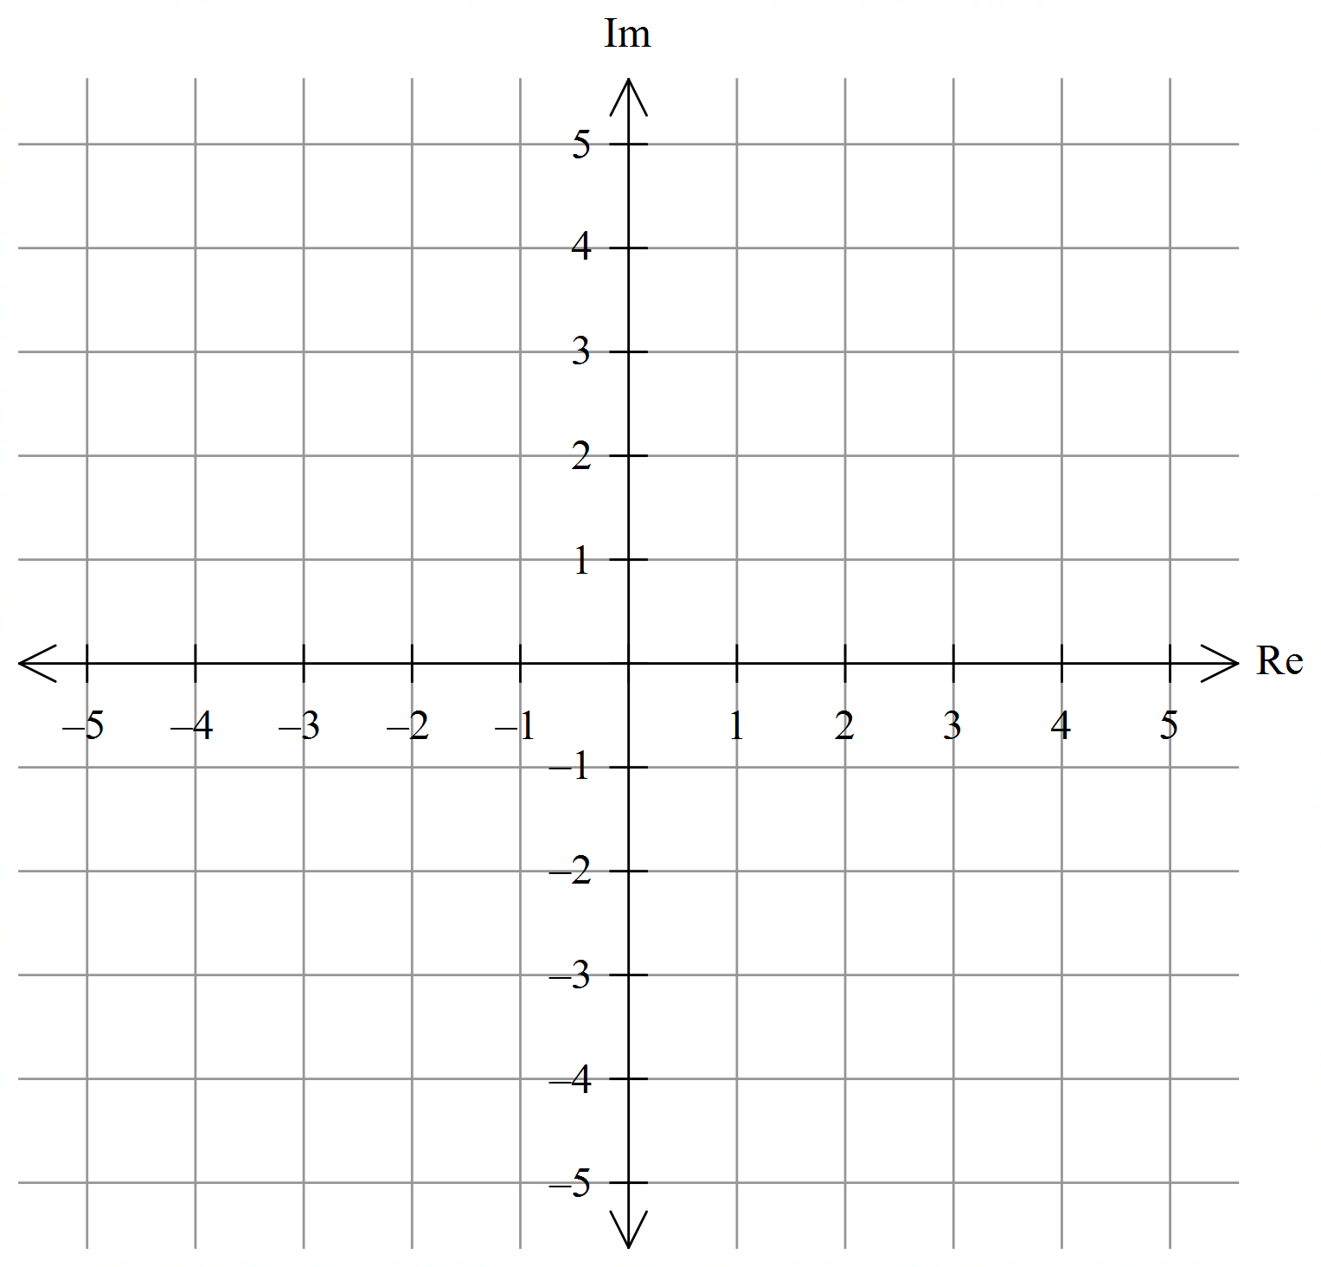
(b) Determine the conditions for a and b in $\left\{\arg\left(z\right)\right.=arg⁡(z+a+\left.bi)\right\}$ to produce infinite solutions and explain any gaps in the set of solutions.

Question 4 [3, 4 = 7 marks]
Sketch and shade the region in the argand plane defined by:
(a) $\left\{z\right.:\frac{π}{4}≤\arg\left(z\right)≤-\frac{π}{4}∩r ≤\left.3\right\}$


(b) $\left\{z\right.:\left|z-2+3i\right|≤\left.\left|z+1+i\right|\right\}$


Question 5 [4 marks]
For $\left\{z\right.:\left|z-3+3i\right|=\left.4\right\}$ determine the minimum possible value of |z| and the minimum arg(z).

Question 6 [4 marks]
Given that $x-1$ is a factor of $F\left(x\right)=x^{4}-6x^{3}-3x^{2}+20x-12$, show that $F\left(1\right)=0$ hence completely factorise $F(x)$.

End of Section One
Additional working space

Question number:___________


MANDURAH CATHOLIC COLLEGE

Complex Numbers

Test 1 2019
Section 2 Calculator-Assumed

MATHEMATICS Specialist Unit 3

Year 12

NAME: ___________________________________________________________________

TEACHER: ____________________________________________________________________

RESULT CA:_______/24

TIME ALLOWED FOR THIS PAPER

Working time for paper: Section 1 = 25 minutes
Section 2 = 20 minutes
Total Time = 45 minutes

MATERIALS REQUIRED/RECOMMENDED FOR THIS PAPER

TO BE PROVIDED BY THE TEACHER

This Question/Answer Booklet
Formula Sheet

TO BE PROVIDED BY THE STUDENT

Standard Items: Pens, pencils, eraser or correction tape, ruler, protractor.
Special Items: Scientific/CAS calculator, 1 A4 (one sided) page of notes

IMPORTANT NOTE TO STUDENTS
No other items may be taken into the classroom. It is your responsibility to ensure that you do not have any unauthorised notes or other items of a non-personal nature in the classroom. If you have any unauthorised material with you, hand it to the teacher BEFORE reading any further.
Instructions to Students

1. ALL questions should be attempted.

2. Write your answers in the spaces provided in this Question/Answer Booklet.

3. SHOW ALL YOUR WORKING CLEARLY. Your working should be sufficient detail to allow your answers to be checked readily and for marks to be awarded for reasoning. Correct answers given without supporting reasoning may not be allocated full marks. Incorrect answers given without supporting reasoning cannot be allocated any marks.

4. If you repeat an answer to any question, ensure that you cancel the answers you do not wish to have marked.

5. It is recommended that you do not use pencil, except in diagrams.

Question 7 [2, 3 = 5 marks]
(a) Multiplying a non-zero complex number by $\frac{1-i}{1+i}$ results in what rotation about the origin on the Argand plane?

(b) The complex number $z=a Cisθ$ and $w=b Cisα$ where $-π ≤θ,α ≤ π$ satisfy,

$$1+z+w=0$$

1, z and w form the vertices of an equilateral triangle on the Argand plane, determine the coordinates of the vertices.

Question 8 [2, 2, 3 = 7 marks]
Given $z=r cis θ$ is any complex number

(a) Simplify $2i\overline{z}$ into $r cis θ$ format.

(b) Determine the nature of the triangle formed by $z-r$ and explain why$θ≠0, π$.

(c) Identify the case where the triangle formed is equilateral and determine an equation for the third side, w, which fits z – r + w = 0.

Question 9 [3 marks]
Given that the complex number $z=a+bi$, determine a and b given $Im\left(\frac{2z+i}{z}\right)=0$ and $Re\left(\frac{2z+i}{z}\right)=10$.

Question 10 [4, 5 = 9 marks]

(a) Given $z^{3}=-1$ determine all solutions in $r cis θ.$

(b) Given $P\left(z\right)=Q\left(z\right).R(z)$ and $Q\left(z\right)=z^{2}-2z+5$ and $R\left(z\right)=z^{3}+1$ solve the following equation giving all answers in $a+bi; -π ≤ θ ≤ π$

$$T\left(z\right)=z^{5}-2z^{4}+5z^{3}+ z^{2}-2z+5$$

End of Assessment
Additional working space

Question number:___________

